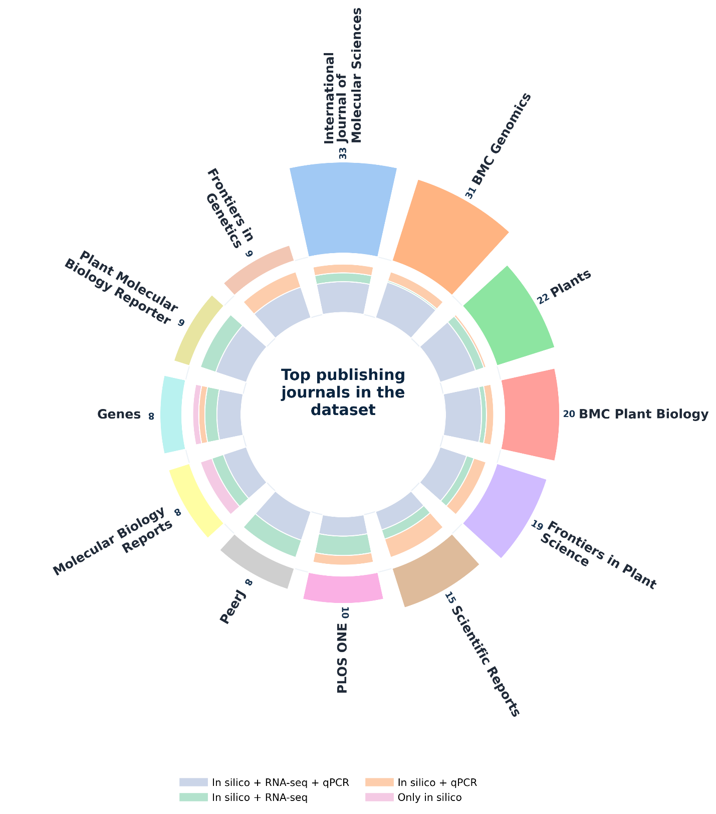
Figure 5. Journal distribution and methodological trends landscape. Radial sunburst plot demonstrating the spread of the research in the top journals. The methodological pipeline of the studies in individual journals is taken as internal rings. Different colors of internal rings represent the use and extent of a particular methodological pipeline.

